Module-V

Topics Page No.

5.1 Shift Registers 2

5.1.1 Serial In Serial Out Shift Register 2

5.1.2 Serial In Parallel Out Shift Register 3

5.1.3 Parallel In Serial Out Shift Register 3

5.1.4 Parallel In Parallel Out Shift Register 3

5.1.5 Bidirectional Shift Register 4

5.2 Shift Register Counters 4

5.2.1 Ring Counter 5

5.2.2 Johnson Counter 5

5.3 Applications 6

5.1 Shift Registers
Shift registers are a type of sequential logic circuit, mainly for storage of digital data. They are a group of flip-flops connected in a chain so that the output from one flip-flop becomes the input of the next flip-flop. Most of the registers possess no characteristic internal sequence of states. All the flip-flops are driven by a common clock, and all are set or reset simultaneously.
There are different kinds of shift registers. That is Serial In - Serial Out, Serial In - Parallel Out, Parallel In - Serial Out, Parallel In - Parallel Out, and bidirectional shift registers.

5.1.1 Serial In - Serial Out Shift Registers

A basic four-bit shift register can be constructed using four D flip-flops, as shown below.
The register is first cleared, forcing all four outputs to zero. The input data is then applied sequentially to the D input of the first flip-flop on the left (FF0). During each clock pulse, one bit is transmitted from left to right. Assume a data word to be 1001. The least significant bit of the data has to be shifted through the register from FF0 to FF3.

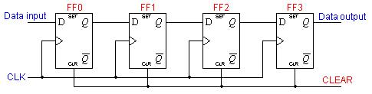

In order to get the data out of the register, they must be shifted out serially. This can be done destructively or non-destructively. For destructive readout, the original data is lost and at the end of the read cycle, all flip-flops are reset to zero.

To avoid the loss of data, an arrangement for a non-destructive reading can be done by adding two AND gates, an OR gate and an inverter to the system. The construction of this circuit is shown below.

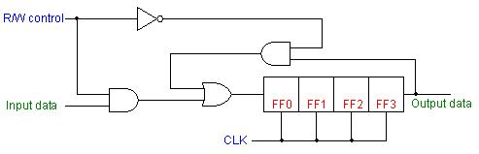

The data is loaded to the register when the control line is HIGH (ie WRITE). The data can be shifted out of the register when the control line is LOW (ie READ).

5.1.2 Serial In - Parallel Out Shift Registers
For this kind of register, data bits are entered serially in the same manner as discussed in the last section. The difference is the way in which the data bits are taken out of the register. Once the data are stored, each bit appears on its respective output line, and all bits are available simultaneously.

Four-bit serial in - parallel out register is shown below.

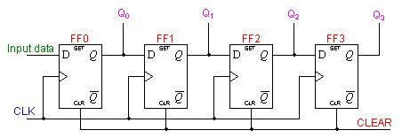

5.1.3 Parallel in - Serial out shift register

A four bit PISO shift register is shown below.
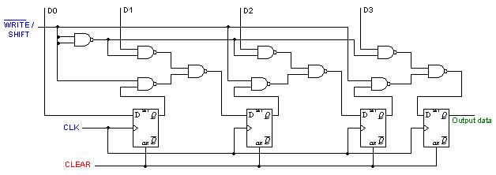

D0, D1, D2 and D3 are the parallel inputs, where D0 is the most significant bit and D3 is the least significant bit. To write data in, the mode control line is taken to LOW and the data is clocked in. The data can be shifted when the mode control line is HIGH as SHIFT is active high.

5.1.4 Parallel In - Parallel Out Shift Registers
For parallel in - parallel out shift registers, all data bits appear on the parallel outputs immediately following the simultaneous entry of the data bits.

The following circuit is a four-bit parallel in - parallel out shift register constructed by D flip-flops.

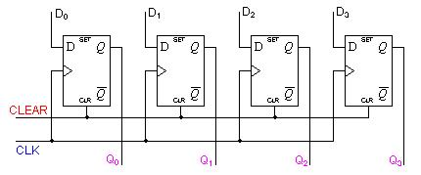

The D's are the parallel inputs and the Q's are the parallel outputs. Once the register is clocked, all the data at the D inputs appear at the corresponding Q outputs simultaneously.

5.1.5 Bidirectional Shift Registers

A bidirectional, or reversible, shift register is one in which the data can be shift either left or right. A four-bit bidirectional shift register using D flip-flops is shown below.

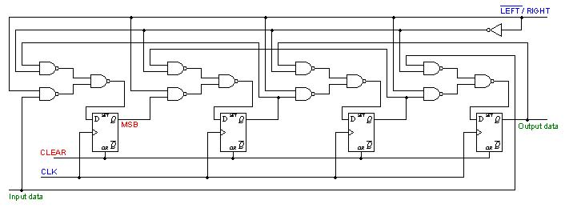

Here a set of NAND gates are configured as OR gates to select data inputs from the right or left adjacent bistables, as selected by the LEFT/RIGHT control line.

5.2 Shift Register Counters

Two of the most common types of shift register counters are the Ring counter and the Johnson counter. They are basically shift registers with the serial outputs connected back to the serial inputs in order to produce particular sequences. These registers are classified as counters because they exhibit a specified sequence of states.

5.2.1 Ring Counters

A ring counter is basically a circulating shift register in which the output of the most significant stage is fed back to the input of the least significant stage.
The following is a 4-bit ring counter constructed from D flip-flops. The output of each stage is shifted into the next stage on the positive edge of a clock pulse. If the CLEAR signal is high, all the flip-flops except the first one FF0 are reset to 0. FF0 is preset to 1 instead.
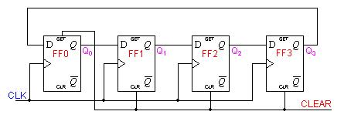

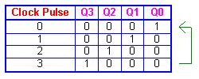
Since the count sequence has 4 distinct states, the counter can be considered as a mod-4 counter. Only 4 of the maximum 16 states are used, making ring counters very inefficient in terms of state usage. But the major advantage of a ring counter over a binary counter is that it is self-decoding. No extra decoding circuit is needed to determine what state the counter is in.

5.2.2 Johnson Counters

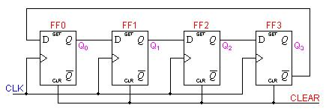

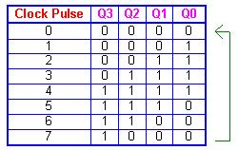

Johnson counters are a variation of standard ring counters, with the inverted output of the last stage fed back to the input of the first stage. They are also known as twisted ring counters. An n-stage Johnson counter yields a count sequence of length 2n, so it may be considered to be a mod-2n counter. The circuit above shows a 4-bit Johnson counter. The state sequence for the counter is given in the table as well as the animation on the left.
The apparent disadvantage of this counter is that the maximum available states are not fully utilized. Only eight of the sixteen states are being used.

5.3 Applications

5.3.1 To produce time delay
The serial in -serial out shift register can be used as a time delay device. The amount of delay can be controlled by:

a) The number of stages in the register
b) The clock frequency

5.3.2 To simplify combinational logic
The ring counter technique can be effectively utilized to implement synchronous sequential circuits. A major problem in the realization of sequential circuits is the assignment of binary codes to the internal states of the circuit in order to reduce the complexity of circuits required. By assigning one flip-flop to one internal state, it is possible to simplify the combinational logic required to realize the complete sequential circuit. When the circuit is in a particular state, the flip-flop corresponding to that state is set to HIGH and all other flip-flops remain LOW.

5.3.3 To convert serial data to parallel data
A computer or microprocessor-based system commonly requires incoming data to be in parallel format. But frequently, these systems must communicate with external devices that send or receive serial data. So, serial-to-parallel conversion is required.

